Q4. Mr. Madhav works in a construction company. To calculate total wages he has developed the following GUI in NetBeans.

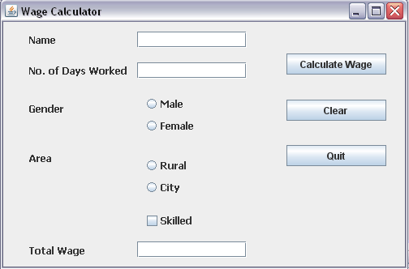

Male and female labourers are respectively paid Rs. 150/- per day and Rs. 170/- per day. Skilled labourers are paid extra at the rate of Rs. 100/- day. Male and female labourers from rural areas are paid 10% less per day.

1. Write the code to lock the text box.( text box for total wages should not take input)
2. Write code to do the following-
3. When Calculate Wage button is clicked, the total wages is calculated as per the given criteria and displayed in total wage text box.
4. When Clear button is clicked, all the text boxes should be cleared and radio button, check box should be deselected.
5. Close the application when Quit button is pressed.

|  |  |  |
| --- | --- | --- |
| Q3. Well Tech Institute offers two post graduate courses, one in computers and one in management. The students can avail certain optional facilities. The basic interface for accepting the details of facilities availed by a student is as follows    MbaRb  LibCb  HostCb  MessCb  CalcBtn  McaRb  EnoTf  LibTfTf  MessTf  HostelTf  ClearBtn | |  |
| Write the code and the event procedures for incorporating the following functionality: | |  |
| (a) | The library facility should be selected by default. And the default course choice should be computers course. |  |
| (b) | When user clicks clear button all the text fields should be cleared. |  |
| (c) | Whenever user selects the HOSTEL facility , the MESS facility should get selected automatically , which the user can deselect later if desired. |  |
| (d) | Given that the charges for library , mess and hostel are RS 500, RS 1500 and Rs 2000 respectively per month , write a method calculate() that calculates and displays the charges per semester, for the facilities . This method should be called when user clicks Calculate button . |  |
| (e) | Make sure that Enrolment Number entered is non negative and non zero value. If it is not give an appropriate message. |  |

|  |  |  |  |  |  |  |  |  |
| --- | --- | --- | --- | --- | --- | --- | --- | --- |
| **Q5.** Ms. Sheela works in a shopping mall. To calculate net payable amount she has developed the following GUI in NetBeans.    **I.** The shop accepts payments in three modes- Cash, Debit Card, Credit Cards. The discount given as per mode of payment is as follows-   |  |  | | --- | --- | | Mode of payment | Discount | | Cash | 12% | | Debit Card | Nil | | Credit Card | 8% |   **II**. If the Member check box is checked then the customer gets an additional discount of 5% on net payable amount.   1. Write the code to make the textfields for Discount( txtDiscount ) and Net Payable (txtNetPayable) uneditable. 2. Write code to do the following- 3. When Calculate button is clicked the discount and net payable amount is calculated as per the given criteria and displayed in discount and net payable text boxes. 4. When Clear button is clicked all the text boxes should be clear. 5. Close the application when Exit button is pressed.. |
|  |

. Mr. Jignesh Desai an owner of Alpha Chemicals PVT ltd has asked his programmer Sweta to develop the following GUI application in Netbeans:

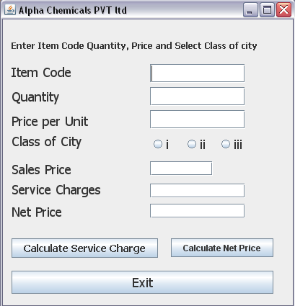

**Service Charges Rates are as follows**

|  |  |
| --- | --- |
| **Class of City** | **Rate of Service Charges** |
| i | 10% of sales price |
| ii | 15% of sales price |
| iii | 20% of sales price |

**Write java code for the following:**

(I) To calculate service charges depending on the selection of radio button

This code will execute after click on the calculate service charges?

Make calculate net price button un-editable.

(II) To calculate net price when Calculate Net price button will be clicked.

Make calculate Service Charges button un-editable.

When exit button will be clicked application should be automatically closed

Read the following case study and answer the questions that follow : ]  
AVON Tools has computerized its billing. The following is the data entry screen in NetBeans IDE used by them :  
 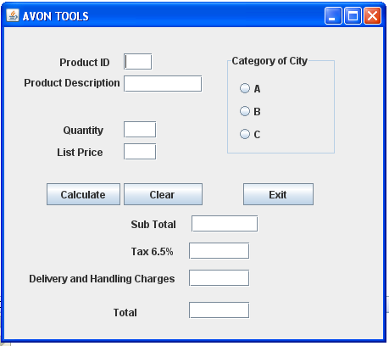  
The list of controls for the above form is as follows :

|  |  |  |  |
| --- | --- | --- | --- |
| Control Type | Control Name | Property Title | Property Value |
| JTextField | JTextField1  JTextField2  JTextField3  JTextField4  JTextField5  JTextField6  JTextField7  JTextField8 | Variable Name Variable Name Variable Name Variable Name Variable Name Variable Name Variable Name Variable Name | txtPID txtDesc txtQty txtPrice txtSub txtTax txtCharge txtTotal |
| JRadioButton | JRadioButton1 JRadioButton2  JRadioButton3 | Variable Name Variable Name Variable Name | optA optB optC |
| JButton | JButton1  JButton2 | Variable Name Variable Name | btnCalc btnExit |

1. When the user clicks Clear Button, all the values stored in the text boxes and option button should be cleared and set the category of the city as A.
2. When the command button with caption “Calculate” (cmdCalculate) is clicked, subtotal, tax (6.50% of subtotal), delivery and handling charges and Total Amount are computed and displayed.  
   The criterion of calculation of Delivery and handling charges is as given below:

|  |  |
| --- | --- |
| Category of City | Charges |
| A B C | Rs. 2,000 Rs. 3,000 Rs. 3,500 |

Sub total is calculated by multiplying Quantity price.

Tax is calculated as 6.50% of Sub Total.

Total is calculated as the sum of sub total, tax, delivery and handling charges.

1. Write the code for Exit Button to close the application.

**Q1.** Write SQL command to create following table with references **[4]**

**DEPARTMENT**

|  |  |  |
| --- | --- | --- |
| **Dname** | **DTeacher** | **Email_id** |
| Hindi | Mr. Amit | Amit@rediff.com |
| Computer | Ms .Anita | AnitaComp@yahoo.com |
| History | Mr. Ravi | Ravi@yahoo.com |

**COACHING**

|  |  |  |  |  |  |  |
| --- | --- | --- | --- | --- | --- | --- |
| **ID (Primary Key)** | **NAME** | **AGE** | **Dept (Referenced)** | **D_of_adm** | **Fee** | **Sex** |
| 1 | RAHUL | 24 | HINDI | 2009-01-10 | 2000 | M |
| 2 | SHAHU | 21 | COMPUTER | 2008-03-24 | 1200 | F |
| 3 | ABHA | 23 | HISTORY | 2010-12-09 | 3000 | F |
| 4 | SUMAN | 25 | HISTORY | 2001-09-09 | 2500 | F |
| 5 | KULKJARNI | 22 | COMPUTER | 2002-05-18 | 4000 | M |
| 6 | ROHIT | 25 | HINDI | 2009-12-17 | 3500 | M |

Write SQL commands to for the following queries:

1. To List the male students who are in HINDI department in ascending order.
2. To display name, age, Fees of Female Students who pay more than 3500
3. To change the fees by adding 500 more in fees for all students of Hindi.
4. To display name, age, dept, dteacher of Hindi and History department.
5. To show the total fees of each department with their teacher name.
6. To delete all the record of students who enrolled before 2008.

Q2 . Create a java application with the following figure: (related to the table Coaching in above question) **[10]**

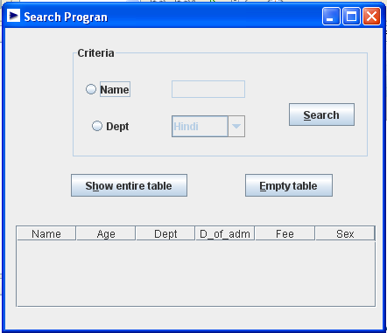

Write coding for

* Show entire table - Show the entire table of Coaching.
* Empty Table - Empty the content of the table from window
* Search – it will search content according to criteria selected
  + Name
  + Department

By default textbox of name and department combo box should be disable and will be enabled when their radio button is clicked.

In a database create two tables ‘company’ and ‘model’ as shown below using referencing: **[4]**

**Company**

|  |  |  |  |
| --- | --- | --- | --- |
| **Compid** | **Compname** | **Comphq** | **Contperson** |
| 1 | Titan | Okhla | C.B.Ajit |
| 2 | Maxima | Shahdara | V.P.Kohli |
| 3 | Ajanta | Najafgarh | R.Mehta |

**Model**

|  |  |  |
| --- | --- | --- |
| **Modelid** | **Compid** | **Modelcost** |
| T020 | 1 | 2000 |
| M032 | 3 | 2500 |
| M059 | 2 | 7000 |
| A167 | 3 | 800 |
| T024 | 1 | 1200 |

Answer the following using SQL:

1. Display compid, compname, modelid, modelcost of each model.
2. Display the total amount of model, comp id and company name for each company.
3. Increase model cost of Titan by 500.
4. Name the model whose headquarter is Shahdara.

II Create the following application in NetBeans and answer the following **[10]**

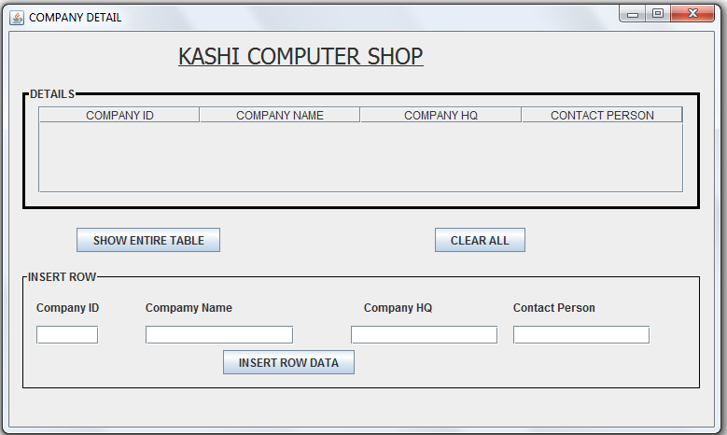

1. Connect the above table and show it completely using show entire table button
2. Clear button will clear all text boxes with table.
3. Insert row data will insert row in original table and also reflect the change in NetBeans.